Sequence Module Design Document

Benjamin Celis 1/17/2019

Contents

Sequencer 1

Sequence 1

Steps 1

Definition 1

Step Configuration 1

Step Runtime 1

Step UI 1

# Sequencer

The sequence will be a Dynamic DCAF module that has the capability to execute the steps defined in a sequence in the order established by the sequence.

## Sequencer Config

Sequence Compiler

This VI Compiles the Sequence into the Standard Sequence String Format that can be used to create a Sequence Object.

Create Sequence

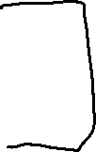

## Sequencer Runtime

The sequencer should be able to publish its state through tags, and also be controlled through tags.

It should have the option to moving to a specific state

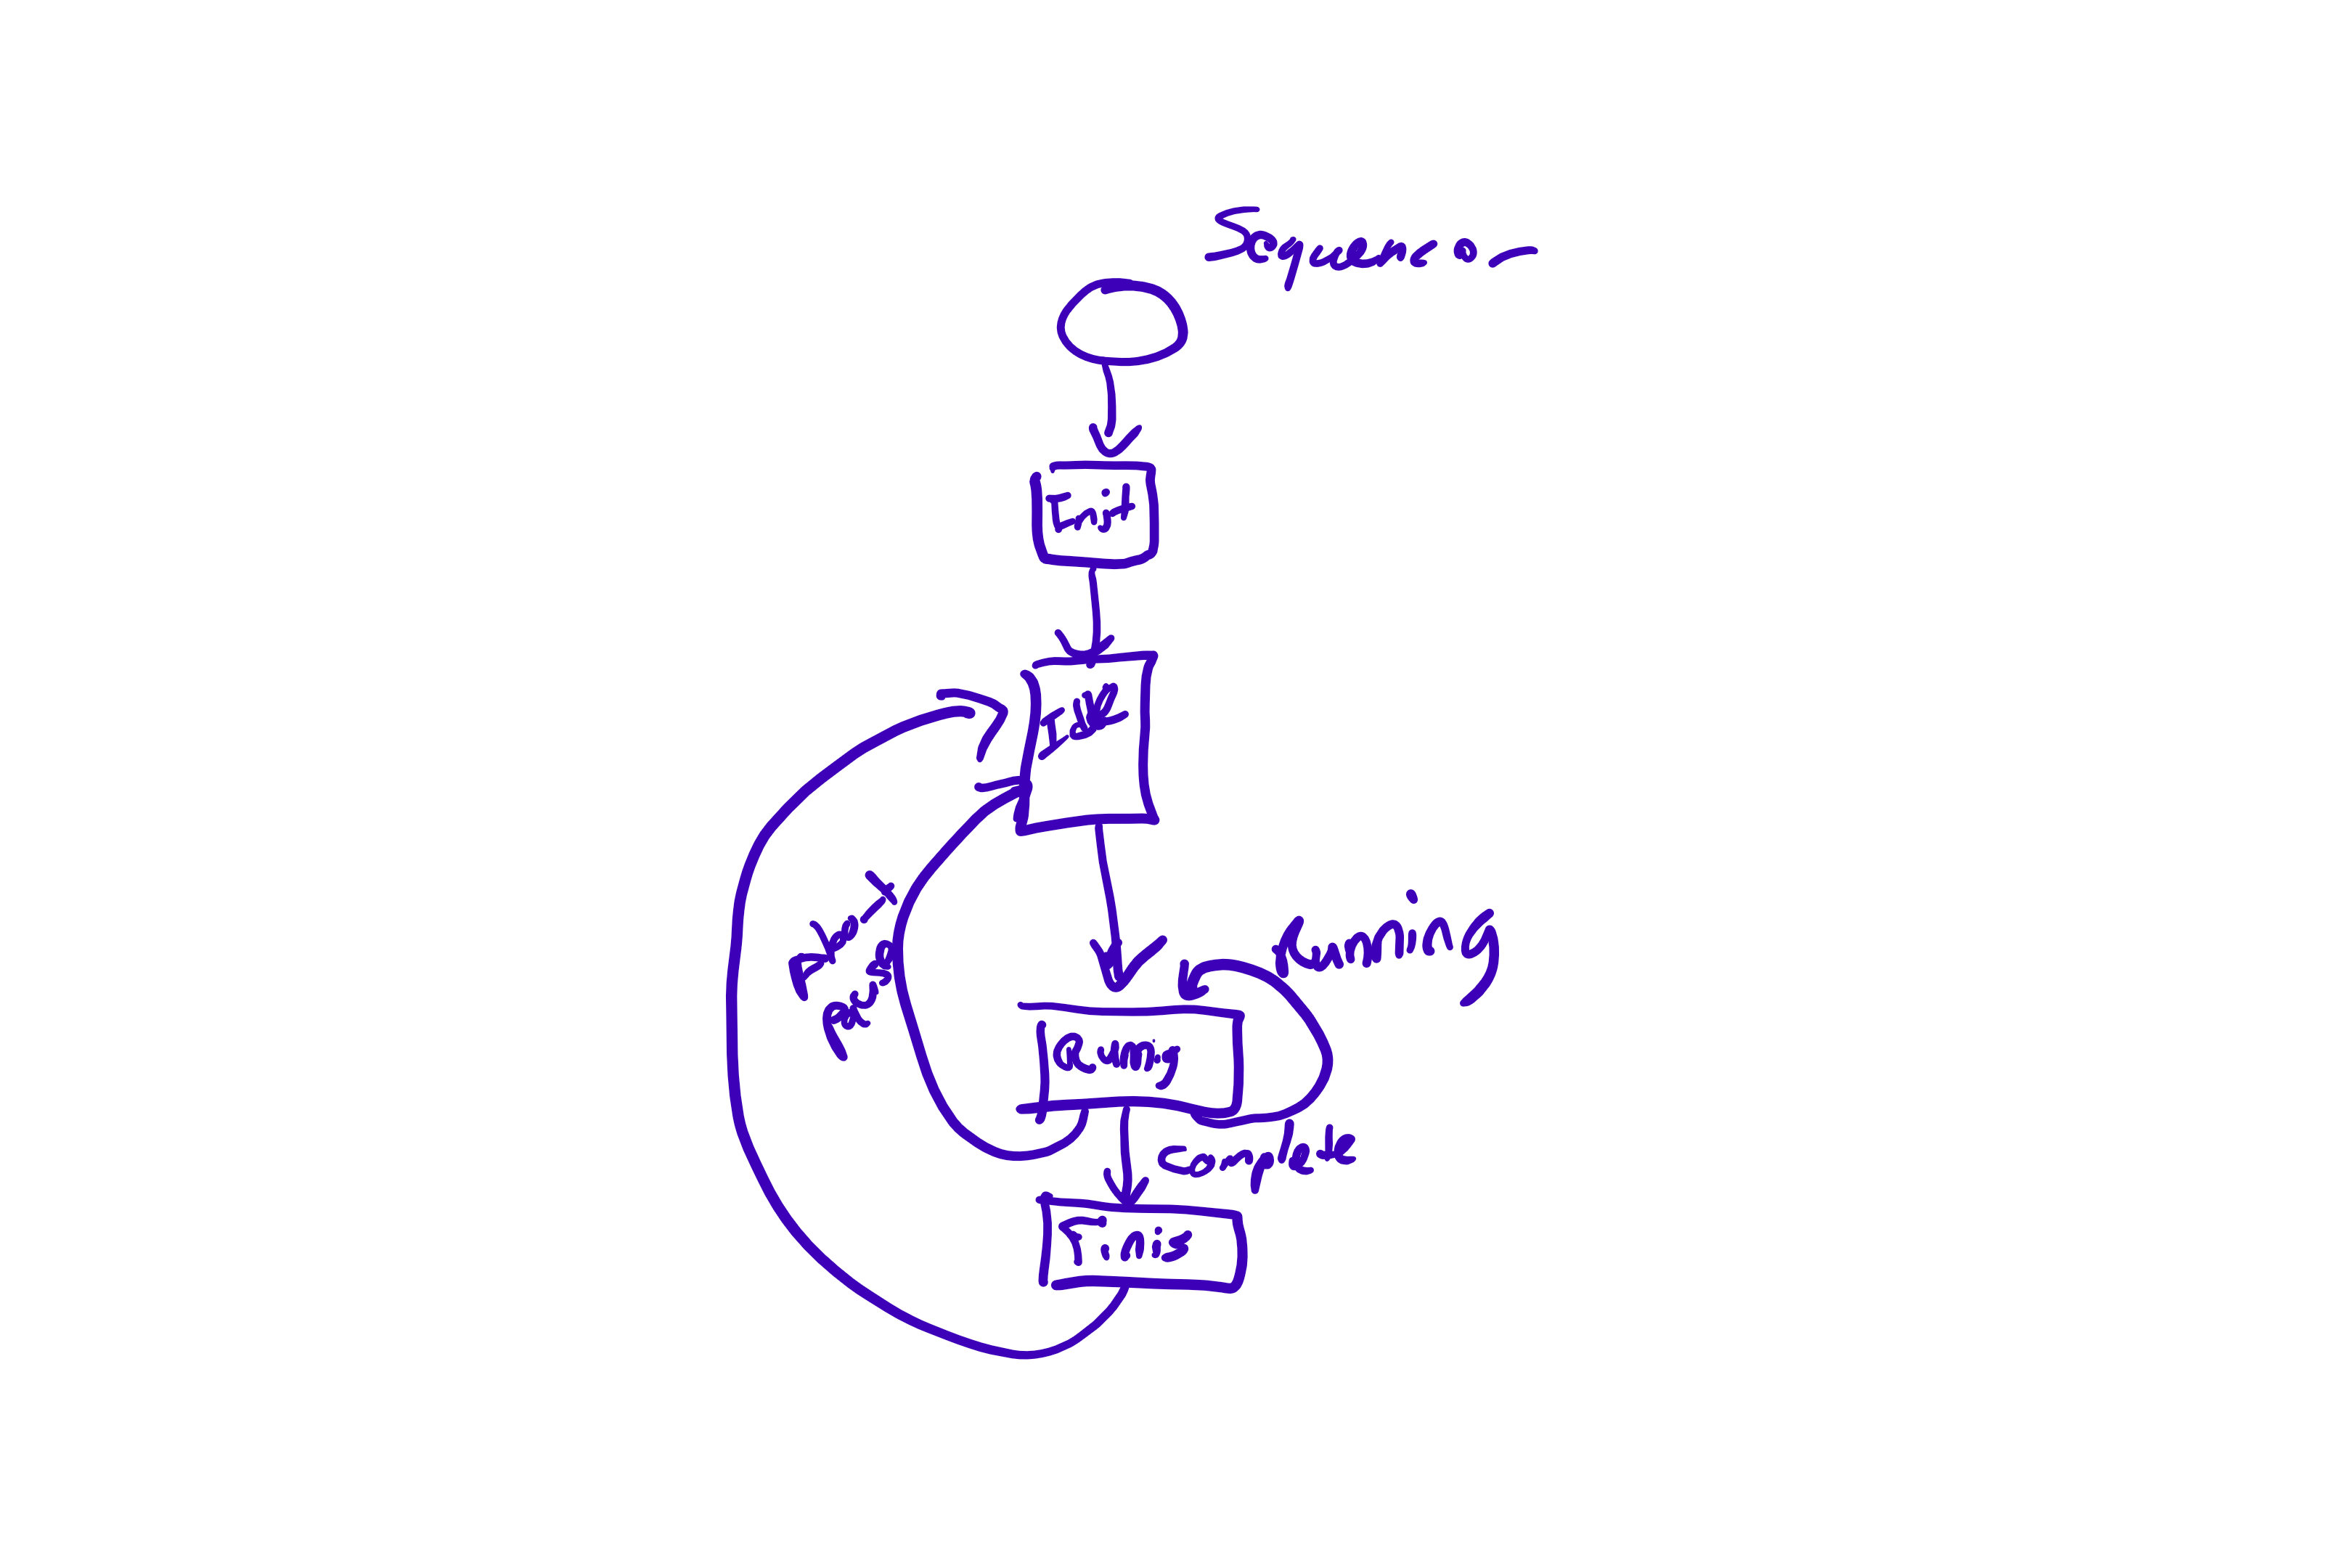

|  |  |  |
| --- | --- | --- |
| Tag Name | Data Type | Description |
| Start | Boolean | Starts the Active Sequence |
| Change Sequence | Boolean | Changes the Active Sequence (only works at the start of the Sequence) |
| New Sequence Number | I 32 | New Sequence Number |
| Pause | Boolean | Sets the Sequence to Idle but keeps track of the active step |
| Abort | Boolean | Finishes the Sequence Skipping the missing Steps |
| Jump to Step | Boolean | Changes the Active Step in the Sequence to the specified Step. Only Works if Paused |
| Step ID | I 32 | ID of the Selected Step |

Table 1 Sequencer Control Tags

Insert table of state tags

|  |  |  |
| --- | --- | --- |
| Tag Name | Data Type | Description |
| Sequencer State | I 32 | I 32 for the value of the enum representing the state. |
| Active Sequence Number | I 32 |  |
| Active Sequence Name | String |  |
| Active Step | I 32 |  |
| Step State | I 32 | I 32 for the value of the enum representing the state. |

## Sequencer UI

There are 2 main components of UI for configurating the Sequencer and not both of them need to be in the DCAF Editor

Option 1:

Stand alone configurator:

* Sequence configurator

Module UI:

* Select Sequences
* Map Tags

Options 2:

This option might give us additional Flexibility and might be the better option.

Module UI:

* Select Sequences
* Map Tags
* Sequence configurator

# Sequence

A sequence represents a group of steps that needs to be executed in a specific order. Users don’t need to create new Sequence Classes. As the instance of the Sequence will be build based on the configuration.

In the Case of DCAF the sequences are represented by 2 Classes:

## Sequence Configuration

This is the configuration interface for the sequencer

|  |  |  |
| --- | --- | --- |
| Property | Data Type | Description |
| Name |  |  |
| Steps |  |  |
| Version |  |  |

## Sequence Runtime

### State Machine

# Steps

## Definition

The step is the basic unit of execution of the sequencer. Each step should know its own state and be able to keep its step information. Step should not use Functional global variables, instead they should use the private data of the class to store this information

Steps should be not blocking.

## Step Configuration

The step Configuration should not include any dependencies to the runtime or UI. The step configuration defines the information that will be saved to a file.

Properties

Runtime Name

Editor Name

Skip

Unique ID

Alias (Label)

Methods

## Step Runtime

Step State

## Step UI

## Template

# Basic Steps

Label

Wait Step

Update Tag

Parallel Step

Conditional Jump